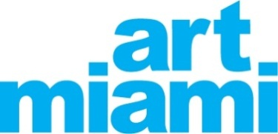
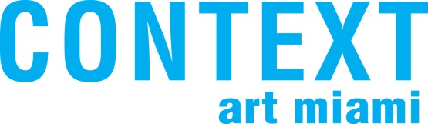

FOR IMMEDIATE RELEASE:
ART MIAMI AND CONTEXT TO HIGHLIGHT EXEMPLARY WORKS,
SPECIAL PROJECTS AND DISTINCTIVE EXHIBITIONS FOR 2014 EDITIONS

MIAMI, Fla. (November 19, 2014) – Art Miami (www.art-miami.com), the city’s original and longest running contemporary and modern art fair, now celebrating its 25th anniversary, together with its adjacent sister fair CONTEXT (www.contextartmiami.com), will present an array of dynamic projects and exhibitions as the anchor event of Art Week in Miami. Established collectors, members of the press, curators, museum professionals and art world luminaries will have first access to view and acquire important works during the VIP Private Preview on Tuesday, December 2, which benefits the Pérez Art Museum Miami and Miami Light Project. The event will also display a luxurious collection of the latest automotive designs from Maserati. Both fairs will then open to the public from Wednesday, December 3 through Sunday, December 7, during which Christie’s International Real Estate will host an interactive booth at the entrance of Art Miami, exhibiting international luxury residential real estate offerings. With a combined exhibition space covering three city blocks and totaling 250,000 square feet, Art Miami and CONTEXT have grown to include a roster of more than 200 galleries, showcasing 1,875 artists from 60 countries around the globe.

Maintaining a preeminent position in America’s contemporary art fair market, Art Miami annually features monumental and compelling artwork from international galleries, including modern masters and the latest in contemporary paintings, drawings, sculpture, photography and prints from Europe, Asia, Latin America, India, the Middle East and the U.S. This year, Art Miami will feature 28 new exhibitors, adding to the elite spectrum of galleries. Now in its third year, CONTEXT will showcase 45 new exhibitors for its 2014 edition.

“We are delighted to once again present and build upon the recent successes of Art Miami and CONTEXT, two distinct fairs that have truly become part of the cultural fabric of the city and Miami Art Week,” said Art Miami Director Nick Korniloff. “The special programming, exhibitions and installations at Art Miami are world-class, and we’re confident attendees will notice and enjoy each fairs’ growth and progressive direction this year.”

Curated exhibitions will be presented throughout the Art Miami and CONTEXT pavilions and outdoor courtyard. Highlights of this year’s special programs include: Perceived Values, Hot Spots, The Director’s Project, A Piece of Me, Art from Berlin, Miami Light Project, 1AN Symposium, a collection of unique Banksy works presented by Keszler Gallery, and a special auction of the official commemorative image created for Art Miami’s 25th Anniversary by cultural icon Jerry Powers.

“The exhibitions and programs at CONTEXT will be even bigger and more impressive than in previous years,” said CONTEXT Director Julian Navarro. “In addition to showcasing a solid group of international galleries, CONTEXT is unique in that it will feature a series of solo artist projects, curated spaces, unique programming, conversations and events – all aimed to immerse and entertain our attendees.”

Details of the unique programming as follows:

Perceived Values provides artists with a space to stretch out with solo presentations in the passageways linking Art Miami’s three main pavilions, showcasing bold installations carefully selected by LaRete Art Projects’ curators: Julia Draganović, Elena Forin and Claudia Löffelholz. Art Miami provides an opportunity for visitors to explore and evaluate the concept of value over the course of the past decade – specifically as it relates to ethics, lifestyle and meaning. At Art Miami, the acclaimed artists on display are Alexandre Arrechea (MagnanMetz Gallery), whose work is imbued with architectural references steeped in history and personal experience; Peter Sarkisian (Modernism Inc.), whose work has an underlying premise of commitment to using video as an instrument against commercialized media, namely television, in order to transform the act of watching video from an experience-killing endeavor to an experience-creating one; Sheldon Scott (CONNERSMITH), who explores race, folk culture, and sexuality in this selection of recent works; and Michael Zelehoski (Mike Weiss Gallery), who’s work, Hue, Value and Saturation, which is commonly thought of as three integral parts of color, refers to the trendy and money-driven aspect of the contemporary art fair that is rapidly reaching the point of saturation.

Other artists featured as part of the highly anticipated Perceived Values space includes: Soly Cissè (Ethan Cohen Fine Arts), Teresa Diehl (Galerie Anita Beckers), Jess Dugan (Catherine Edelman Gallery), Eldon Garnet (TORCH), Wen Hao (Klein Sun Gallery), Bob Snead (Arthur Roger Gallery), Simón Vega (Galerie Ernst Hilger), and Peter Weber (Galerie Renate Bender).
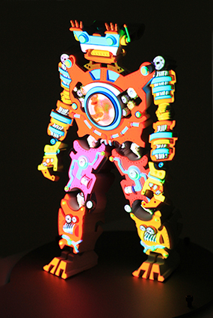
Peter Sarkisian, VideoMorphic Figure (Robot 5, Version 3), 2014, Sintered 3D print, powder coated steel and aluminum, video projection, audio, 14 x 14 x 40 inches
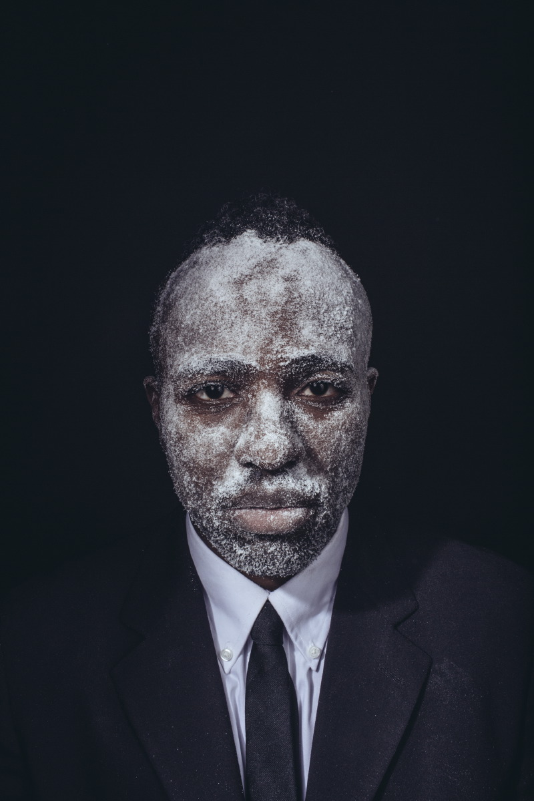
Sheldon Scott, Self Portrait as John Henry (Hammer), 2014, c-print on archival paper,
26 x 38 inches, ed: 10
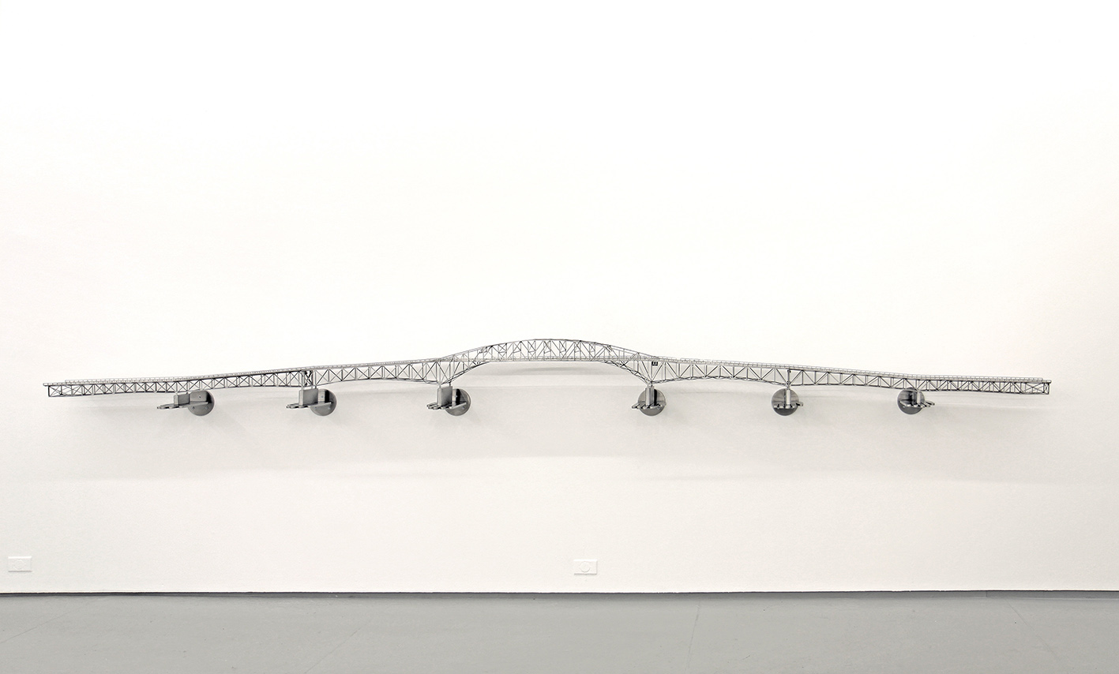
Alexandre Arrechea, Last Days of Champlain, 2012, stainless steel,
14 1/2 x 188 1/2 x 12 inches

HOT SPOTS, also curated by LaRete Art Projects’ esteemed team, positions provocative installations and projects by individual artists whose galleries are participating in the fairs. At Art Miami, the three artists on display are Jaildo Marinho (Durban Segnini Gallery), a Brazilian native whose work is focused on geometry and abstraction; Victor Matthews (KM Fine Arts), an internationally exhibited artist who has been working on the recognizable “White Paintings” series for past decade; and Antonio Pio Saracino (Todd Merrill Studio), an Italian-born artist, architect and designer who will present a marble sculpture “The Guardians: Hero” which is a reinterpretation of Michelangelo’s “David”. The 8,000-pound piece sits at 13-feet-high and is a permanent exhibition in New York City’s Bryant Park.

At CONTEXT, the seven artists on display and respective galleries presenting their work are Peter Demetz (White Room - Liquid art system), Héctor Falcón (Galería Enrique Guerrero), Grant Irish (ten472 Contemporary Art), Susan Kleinberg (VOHN Gallery), Lee Jeong Lok (Shine Artists), MARCK (LICHT FELD Gallery), and Antonio Sannino (White Room - Liquid art system).
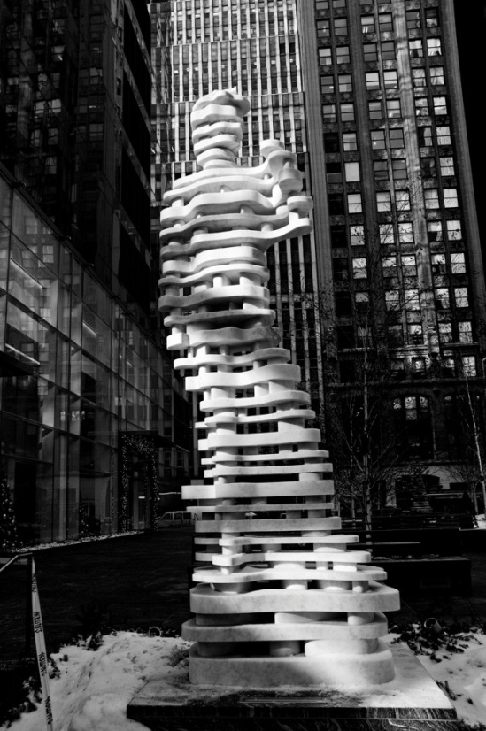
Antonio Pio Saracino, The Guardians: Hero, 2014, Danby Stone (statute), Petite granite (base), Statue 6.5 x 2.5 x1.5 ft; Base: 31 x 31 in.; Photo: Alexo Wandael
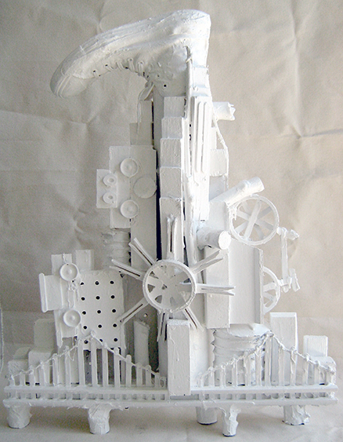
Victor Matthews, Frozen City VII, 2013,
Wood, canvas, sneaker, cardboard and paint, 28 x 19 x 7 in.

Art From Berlin offers insight into Berlin’s influential art scene with six contemporary galleries selected by a panel of Berlin-based curators and art critics. In the BERLIN LOUNGE, the Galleries Association of Berlin (lvbg) will install a curated exhibition and offer information on the city’s contemporary art galleries and institutions, featuring Freundeskreis Willy-Brandt-Haus e.V. This microcosm of the global art capital's gallery community includes a cross-section of established and emerging exhibitors, including Galerie Friedmann-Hahn, Galerie Kornfeld, Läkemäker, Grundemark Nilsson, Tammen & Partner, and Wichtendahl Galerie. Art From Berlin is presented with official support from the municipality of Berlin and the European Union (EU).
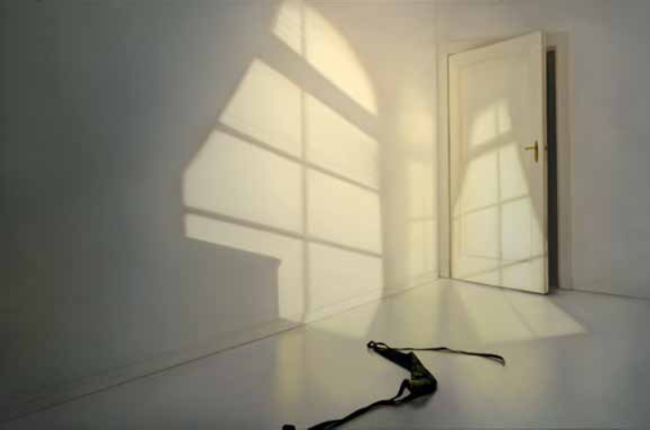
Edite Grinberga: Tür ins Dunkel, 2014, oil on canvas, 130 x 200 cm
Presented by Galerie Friedmann-Hahn

The Director’s Project, CONTEXT-ing / Listening as CONTEXT, creates immersive and intimate situations for listening to the work of sound artists exploring the ontological aspects of sound, while also working with various materials, approaches and techniques. CONTEXT-ing / Listening as CONTEXT will be premiered on the VIP opening night in a 2,600-square-foot Sound Positions Pavilion, a dedicated space annexed to the main CONTEXT pavilion featuring 12 individual sound stations, presenting the largest sound project ever showcased at an art fair, and continues through the fair. Artists include Tania Candiani, Mexico; Richard Chartier, U.S.; Richard Garet, Uruguay/U.S.; France Jobin, Canada; Emeka Ogboh, Nigeria; Kristin Oppenheim, U.S.; Manuel Rocha, Mexico; Steve Roden, U.S.; Hong-Kai Wang, Taiwan; Hildegard Westerkamp, Germany/Canada; Jana Winderen, Norway; and Zimoun, Switzerland.
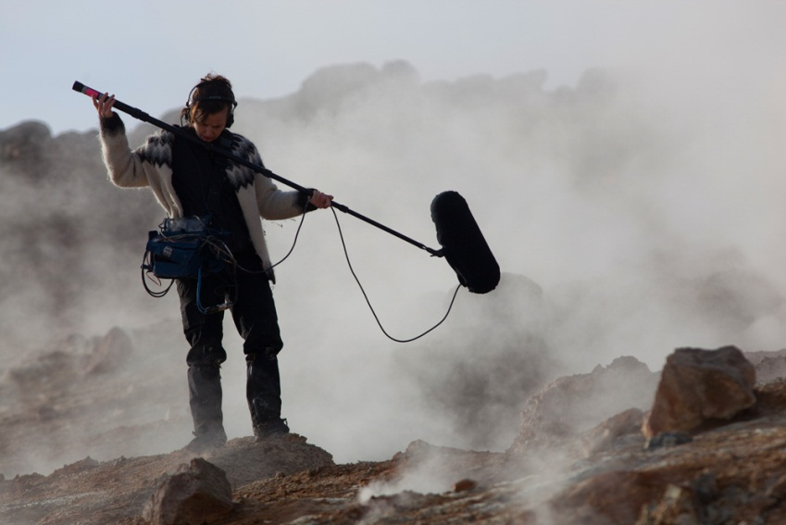
Jana Winderen recording in Iceland. Photo by Finnbogi Petursson
A Piece of Me features visual arts students from the high school honors class of Miami's renowned New World School of the Arts, collaborating to produce site-specific installations in response to a significant artwork by an acclaimed alumnus from their school, Hernan Bas. The young collaborators will work in the antithetical medium of paper, and the results exhibited with the video by their predecessor.
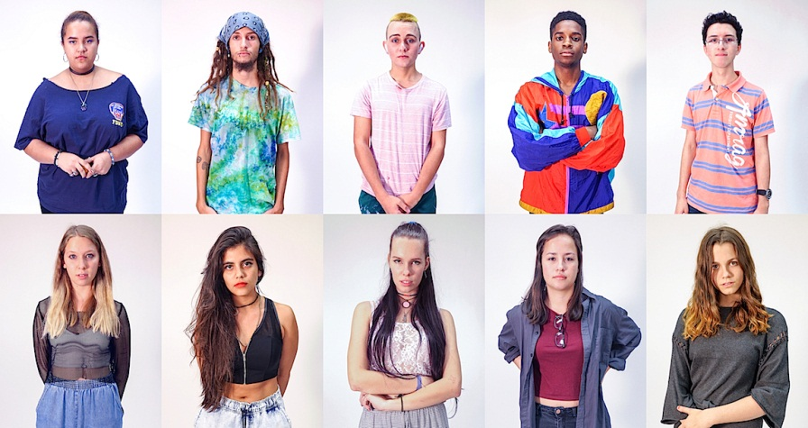
Image courtesy of Wet Heat Project

New York-based Keszler Gallery will present a unique collection of works by famed English street artist Banksy, representing some of the artist’s most important pieces from 2005 through today. Several of the original works, including spray paintings and mixed media sculptures, were created during his month-long New York City residency in 2013 and featured in HBO’s recent documentary “Banksy Does New York.”
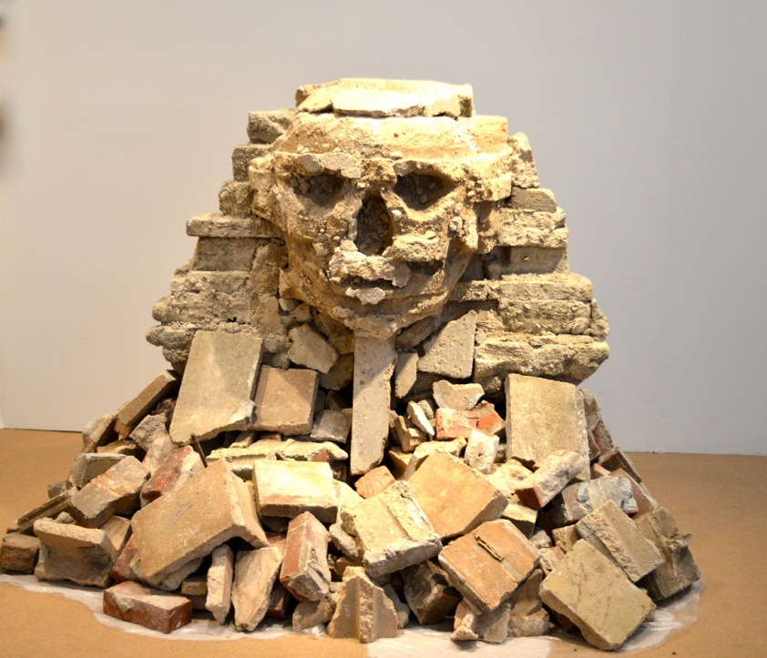
Banksy’s “Sphinx” New York, 2013
From NYC “Better Out Than In” Series: October 22; Mixed media sculpture
50 x 54 inches; original street work

An auction of the official Art Miami 25th Anniversary commemorative painting will take place during Art Miami’s VIP Private Preview on December 2, to benefit PETA. The irreverent acrylic-on-reverse-canvas titled “Art Miami” was created by Jerry Powers, founder and publisher of Ocean Drive magazine and local cultural icon, who is making his debut as an artist with this piece. Art Miami director Nick Korniloff also secured the piece to serve as Art Miami’s 25th anniversary official limited edition poster, which will be sold through Swampspace Gallery. Powers will also exhibit eight original pieces at CONTEXT through the duration of the fair.
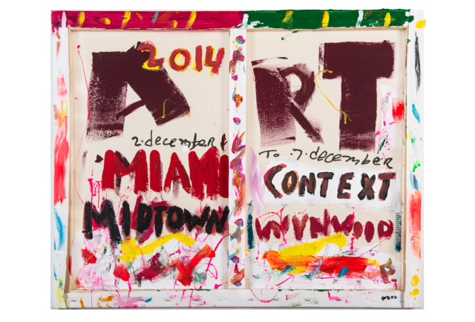
“Art Miami,” by Jerry Powers
Acrylic on reverse canvas, "24 X 30" 2014 courtesy collection of PETA

Miami Light Project will partner with CONTEXT for the highly anticipated Opening Night VIP Preview. Latin Grammy Nominated artist/producer Mr. Pauer will perform an exclusive selection of his signature sound Electrópico™ filled with live percussion and an array of guest singers, turning the night into a memorable experience. Miami Light Project will stage a selection of performances that will take place in the CONTEXT Outdoor Garden Lounge daily during all general fair days.

1AN Symposium, presented by One Art Nation, will take place December 5-7 starting at 1 p.m., bringing together leading opinion leaders and industry experts to speak on a variety of art topics including valuation, security, shipping, storage, restoration, authenticity and more.

The Children’s Art Center will provide a safe, on-site playroom at Art Miami for children ages 3-13, who will be introduced to art while their parents visit the fairs. Kids enrolled in the program will have exclusive access to participate in activities including art explorations, games, puzzles and storytelling. The center will be open Wednesday through Saturday, 11 a.m.–7 p.m. and Sunday 11 a.m.–5 p.m.

GENERAL INFORMATION
Art Miami and CONTEXT, December 2–7, 2014
VIP Private Preview Event:
December 2, 2014, 5:30–10 p.m.
General Operating Hours:
December 3 – 6, 2014, 11 a.m. – 8 p.m.
- December 7, 2014, 11 a.m. – 6 p.m.
Location:
Art Miami: The Art Miami Pavilion, Midtown, Wynwood Arts District, 3101 NE 1st Ave., Miami,
FL 33137
- CONTEXT: The Art Miami Pavilion, Midtown, Wynwood Arts District, 2901 NE 1st Ave., Miami,
FL 33137
Admission:
One-day fair pass (Art Miami and CONTEXT) - $35
One-day fair pass including catalog (Art Miami and CONTEXT) - $75
Multi-day fair pass (Art Miami, CONTEXT and Aqua) - $75
Multi-day fair pass including catalog (Art Miami, CONTEXT and Aqua) - $105
Students 12-18 years and seniors - $15
Children under 12 years accompanied by adult - Free
Groups 10 or more - $15

For the latest updates on Art Miami and CONTEXT, and a full list of the 2014 exhibitors, visit www.art-miami.com, www.contextartmiami.com

About Art Miami LLC
Art Miami LLC is a preeminent art fair organization that annually produces: Art Miami, CONTEXT and Aqua Art Miami in December; Art Wynwood in Midtown Miami over President’s Day Weekend; New York City’s Downtown Fair in May; Art Southampton in July; and Art Silicon Valley/San Francisco in October. Art Miami LLC is a partnership consisting of art and media industry veterans Nick Korniloff, Mike Tansey and Brian Tyler.

Sponsors & Partners
The generous 2014 sponsors and partners for Art Miami and CONTEXT include: Christie’s International Real Estate – Official Luxury Real Estate Partner of Art Miami, JW Marriott Marquis Miami and Hotel Beaux Arts Miami – Official Luxury Hotels of Art Miami, Maserati North America – Official Luxury Automobile and VIP Lounge Host, Pérez Art Museum Miami – VIP Preview Partner, Bourlet Art Logistics – Official Art Handling and Transport Provider, Turon Travel, Onkyo, Haute Living, Greater Miami Convention and Visitors Bureau, Midtown Miami, Heineken, Société Perrier, Flavorpill, LaRete Art Projects, Art From Berlin and the Galleries Association of Berlin (lvbg), Spuntino Catering, Bakehouse Art Complex, Boca Museum of Art, Museum of Contemporary Art North Miami, Nova Southeastern University, Museum of Art | Fort Lauderdale, Mutual Art, Artfacts.Net, artprice.com, ArtForbes.com, International Sculpture Center and Sculpture Magazine, Art in America, The Art Newspaper, Art + Auction, Blouin ArtInfo.com, Art & Antiques, Hyperallergic, Artlog, Art Nexus, Arte Al Día, art ltd., Artillery Magazine, ANNUAL Magazine, IRREVERSIBLE magazine, ART OnCuba, Art Circuits Guide and Maps, Around Town Magazine, The Miami Herald, The New York Observer, Manhattan Magazine, Social Life Magazine, Private Air Luxury Homes, Balthazar, South Florida Luxury Guide and VENÜ MAGAZINE.

Press Contact:
Courtney Grinnell or Nicole Kraft at Glodow Nead Communications, 415-394-6500, ArtMiami@glodownead.com

# # #

